**Assignment 2**

Member

Bowen Zhang s3617571

Cheng Chen s3728207

Bowen Yang s3665803

Zongming Liu s3713771

Lei Guo s3516439

Zheshun Shi s3696260

# 

**Team Member** **2**

**Project Description** **4**

**Core Features** **5**

Core Feature 1 5

Core Feature 2 6

Core Feature 3 6

Core Feature 4 8

Core Feature 5 8

**Extended Features** **9**

Extended Feature 1 9

Extended Feature 2 11

Extended Feature 3 12

**Project Estimation** **13**

**Technology Listing** **14**

Collaborative Workspaces 14

Software 14

Tools 16

Resources 17

# Team Member

**Bowen Zhang s3617571**

**Background & Passion** - Basic coding skills and passionate about games and Artificial Intelligence.

**Skill & Interest** - Good at Coding, Learning and organizing and interested in all sorts of games and AI or advanced technologies.

**Weakness** – I’m not good at English writing.

**Role** – Organiser & programmer

**Cheng Chen s3728207**

**Background & Passion** - Had basic coding experience with VS, Pascal,

Python and Java. Strong interest in building a software.

**Skill & Interest** - Enthusiast of hardware and game building, Good at organising. Interested in coding and function developing.

**Weakness** - Weak at visual design.

**Role** - Mainly working on software structures and feature design.

**Bowen Yang s3665803**

**Background & Passion** - I have basic experience with Java programming language and program interface design.

**Skill & Interest** - Better at text editing than coding, but I am working hard to learn programming and are interested in the IT words.

**Weakness** - Probably the coding skills need to improve.

**Role** - I expect to become a competent team member that be able to do a good job of assigning tasks and be able to present their own views on the project.

**Zongming Liu s3713771**

**Background & Passion** - I know some basic coding skills and static web layout coding skills.

**Skill & Interest** - I am good at designing the website

**Weakness** - weak at coding

**Role** - design the UI and interface of the app

**Lei Guo s3516439**

**Background & Passion** - I have basic coding skills in Java, .net and web programming.

**Skill & Interest** - Good at teamwork and interesting in computer games and travelling

**Weakness** - Weak at English

**Role** - Good team member

**Zheshun Shi s3696260**

**Background & Passion** - basic Java and web programming skills.

**Skill & Interest** - interested in VR.

**Weakness** - weak at English grammar and oral speaking.

**Role** - perfect teammate.

# 

# 

# Project Description

Our team is building a mobile application called Litab which is a combination of Tally book and Reminder. The main purpose of this application is to keeping track on personal expense and to remind user what’s coming next and what they want to buy or do in the future. Users can plan their future expense based on their monthly average spending and income and users can categorize their expense for better management. The application will also tell the user if their plan have fulfilled or short by how much as well, remind them if they need to cut their budget or create extra income to achieve their goal. Finally, this app will feature all the basic function a tally book has such as list all consumption, categories and a clean and friendly interface.

# Core Features

## Core Feature 1

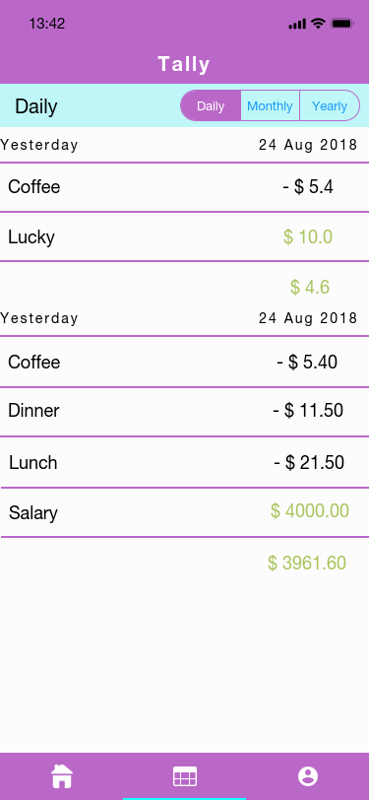

Core Feature 1 Validation Testing:

Check the income and outcome categories.The users can check the categories by daily, monthly or yearly. The app will calculate the statement. They also can click each category to change the details. If the app prompts for valid categories, we can make sure that every data is recorded into the correct category.

**Author: Bowen Zhang Create Date: {26/08/2018 }**

## Core Feature 2

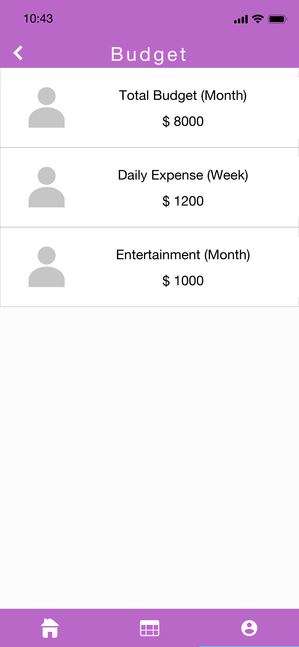

Core Feature 2 Validation Testing:

Set the budget for weekly and record some data to perform overspend. The users can also set the Daily expense, Entertainment budget or other budgets. If the app shows an alarm when the current spending value exceeds the budget set, this function is working properly.

**Author: { Cheng Chen} Create Date: {26 /08/2018 }**

## Core Feature 3

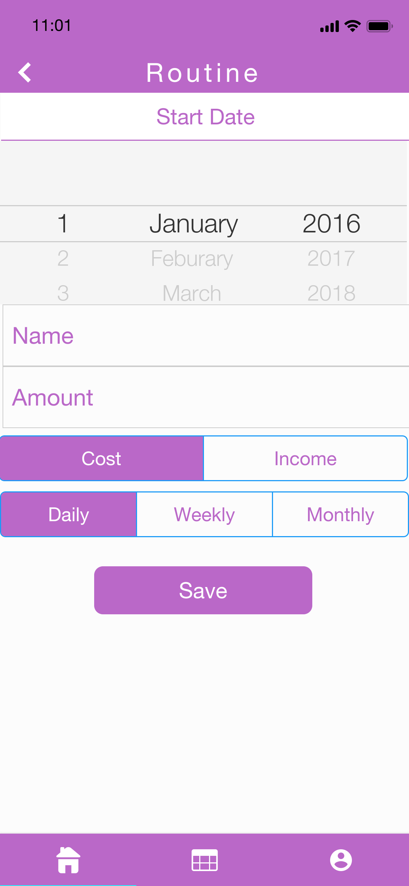

Core Feature 3 Validation Testing:

Input some name in the category creation menu. The app will record the data. If the category shows up on the spending input page, this function is working properly

**Author: { Bowen Zhang } Create Date: { 26/08/2018 }**

## Core Feature 4

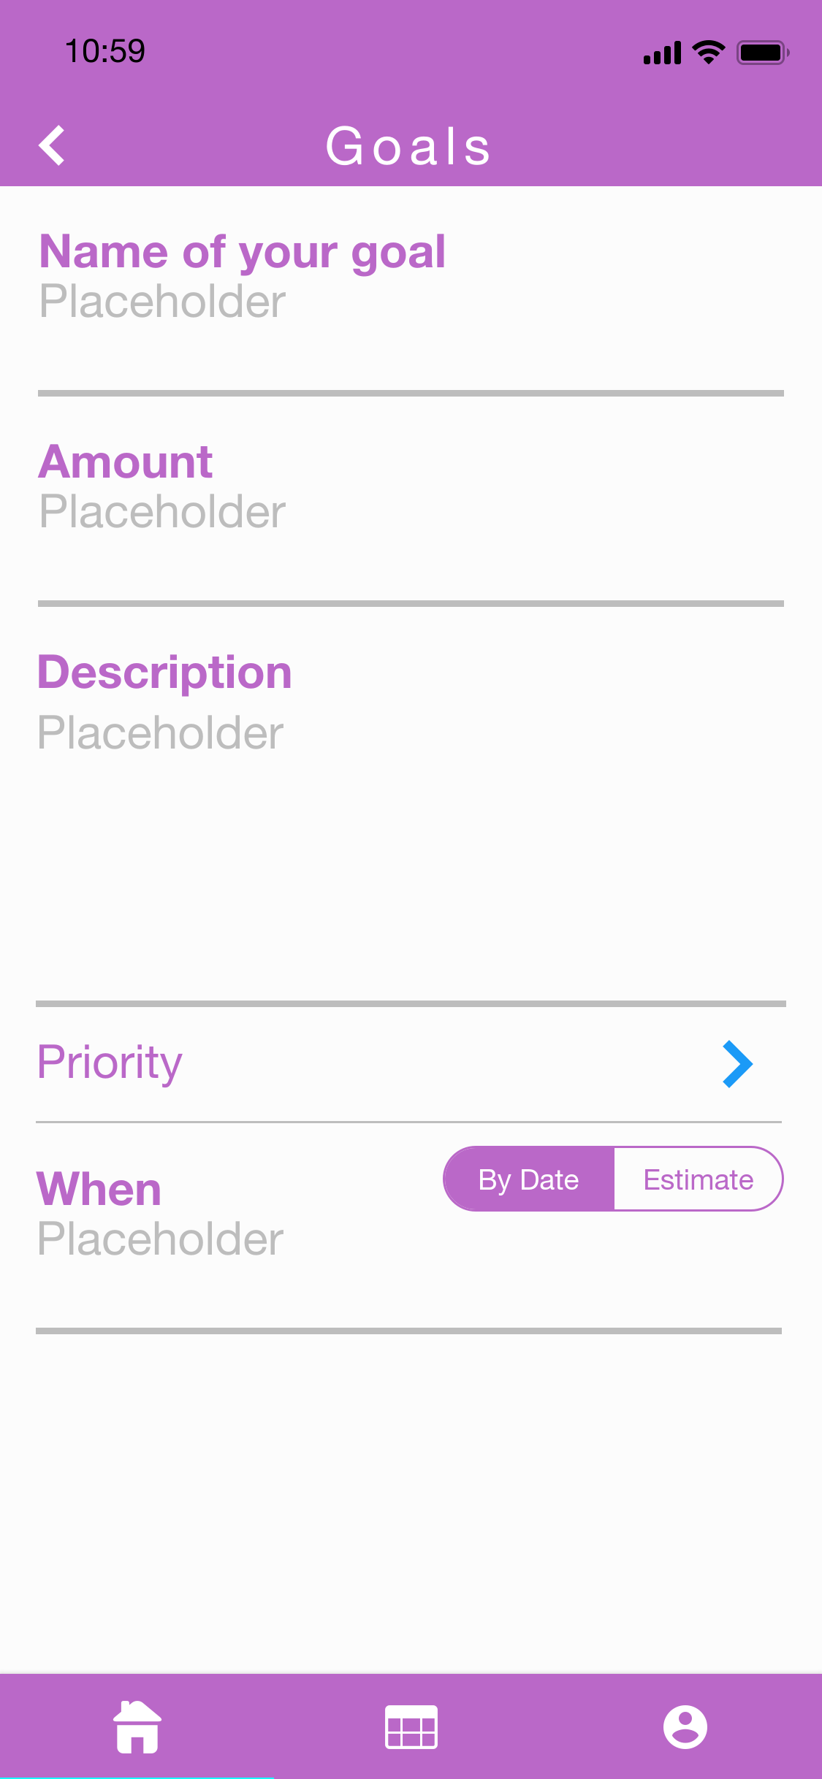

Core Feature 4 Validation Testing:

Set a target in money box with preferred purchase date. If the users choose the “By date”, the users can set the date and the app will calculate the money the users need to save everyday. If the users choose the “Estimate”, the app will calculate the time by the expense history that users will know how many days they need to wait. Users can see the details of all the things. If the app correctly shows the amount of money needed to be saved each week, this function is working properly.

**Author: { Bowen Zhang } Create Date: { 26/08/2018 }**

## 

## Core Feature 5

Core Feature 5 Validation Testing:

Set some notes and reminders. If the notes are correctly displayed, the notes function is working properly. If the alarm goes off at the desired time, the reminder function is working properly.

**Author: { Bowen Zhang } Create Date: { 26/08/2018 }**

# 

# 

# 

# 

# 

# 

# Extended Features

## Extended Feature 1

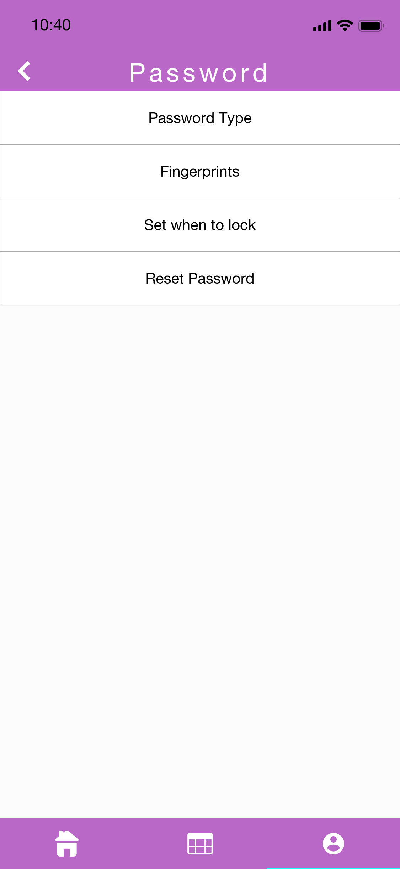

Extended Feature 1 Validation Testing:

Input a valid username and password. If successfully logged in, it is working properly. Input an invalid username or password. If the login failed, the login function if fully working.

**Author: {Cheng Chen } Create Date: { 07/09/2018 }**

## Extended Feature 2

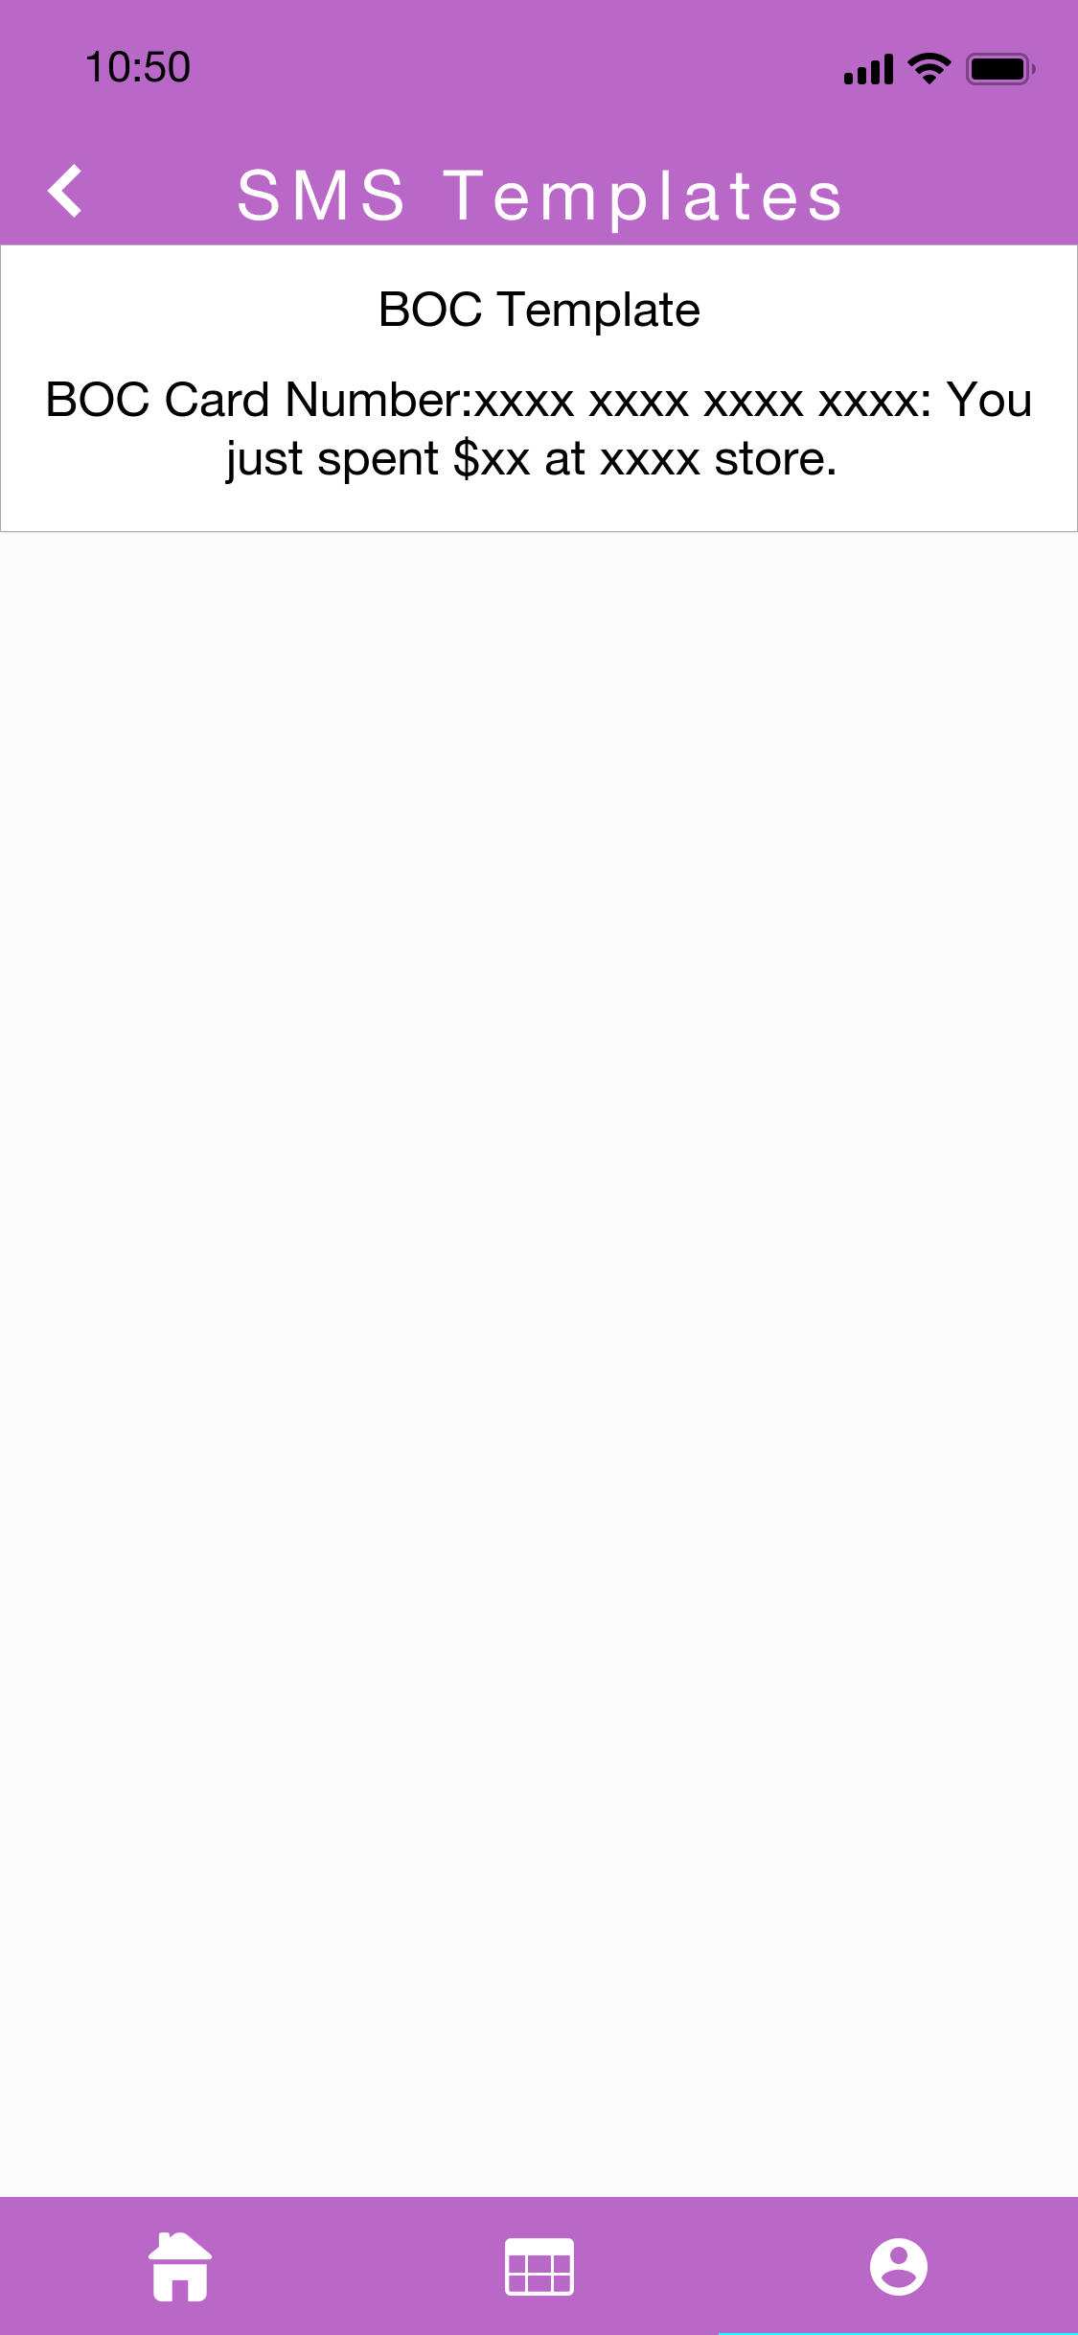

Extended Feature 2 Validation Testing:

Set a template and test with some text messages corresponding to the template. If the app recognizes the text message and records the correct value in the text, this function is working properly.

**Author: {Cheng Chen } Create Date: { 07/09/2018 }**

## Extended Feature 3

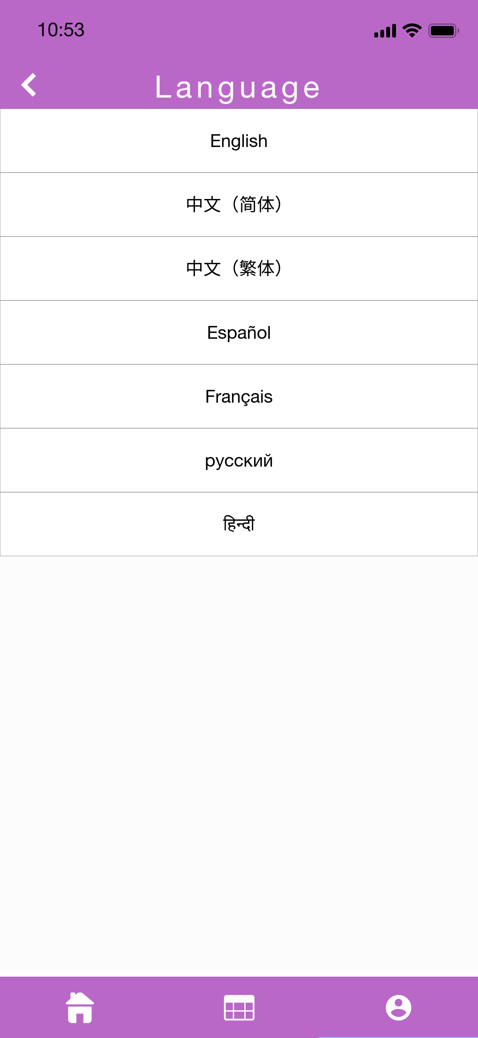

Extended Feature 3 Validation Testing:

For different users from different countries can use the app. If the users can choose the language they use, this function is working properly.

**Author: {Cheng Chen } Create Date: { 07/09/2018}**

# Project Estimation



 

 

 

 

 